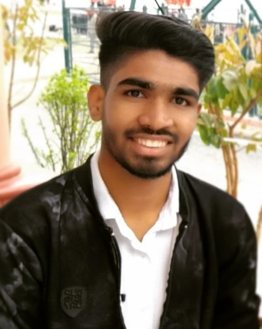

Name-Satyadev Saini

# Mobile-9027294541

Email - [Satyadevsaini07@gmail.com](mailto:Satyadevsaini07@gmail.com)

LinkedIn- [www.linkedin.com/in/satyadev-saini-7b4073231](http://www.linkedin.com/in/satyadev-saini-7b4073231)



**CAREER OBJECTIVE**

Goal to work in a organization as a **Java Full Stack Developer** where I could enhance my knowledge and abilities, To become a successful expert in the field of Information Technology by channelizing my technical knowledge and skills to ensure personal and professional growth and to contribute to the prosperity of the organization.



**PROFESSIONAL QUALIFICATION**

Bachelor of Computer Application. (**BCA**)

Master’s in Computer Application. (**MCA**)



**ACADEMIC QUALIFICATIONS**

|  |  |  |  |  |
| --- | --- | --- | --- | --- |
| **EXAMINATION** | **BOARD/UNIVERSITY** | **SCHOOL/COLLEGE** | **YEAR OF PASSING** | **CGPA** |
| MCA | Chandigarh University  , Mohali | Chandigarh University  , Mohali | Pursuing  (Batch 2021 - 23) | ----- |
| BCA | Uttaranchal University  , Dehradun | Uttaranchal Institute of  Management | 2018-21 | 8.0 |
| Intermediate | CBSE Board | Khalsa Public School | 2018 | 6.5 |
| High School | CBSE Board | Khalsa Public School | 2016 | 9.4 |



**TECHNICAL SKILLS**

**JSE** (Fundamentals, OOP, I/O, Multithreading, Exception Handing, JDBC, Collection Framework etc.),

**JEE** (Servlet, Session, Cookies, JSP, JSTL etc.),

**Database** (My SQL),

**Frameworks**

**Spring Core** (Inversion of Control, Dependence Injection, Maven etc.)**,**

**Spring Boot AOP** (Understanding Aspect, Advice, Joinpoint, Pointcut etc.)**,**

**Spring Boot MVC** (Understanding MVC, File Uploading and Downloading, Exception Handling etc.)**,**

**Spring Boot RESTful WebService** (Building RESTful Webservice, Rest Controller, Postman, RESTful

Service Simple Client, RESTful Service Web Client etc.)**,**

**Spring Boot Security** (In Memory Configuration, Database Login Logout, Authorization Using Oath2).



**PROJECT WORK**

**Platform: Java (MVC based Project)**

**(Garage Management**: In project I have 3 types of login 1. Admin: Manages the Garage Owner will

create Account or not! 2. Garage Owner: Garage Owner will create the Account and add the features of

his/her garage. 3. User: will check the location of Garage and search about garage and its features.



**SKILLS**

Microsoft Visual Studio, Eclipse IDE 2021-09, Apache NetBeans12.6, Microsoft SQL Server 2008, Postman, Notepad++, SpringToolSuite4.

## LINGUISTIC PROFICIENCY KEY SKILLS AND ATTRIBUTE

* Hindi Interpersonal skills.
* English Team work skills. Leadership skills.

PROFESSIONAL INTERNSHIP / CERTIFICATIONS

Core Java Technology. (ID: S22/9821/1026)

Advance Java Technology. (ID: S22/9821/1026)

Spring Framework Technology. (ID: S22/9821/1026)



**CO-CURRICULAR ACTIVITIES & AWARDS**

* Won Prizes in Cricket at State Level events.
* Participation in Coding in University event.
* Involved in organizing and participated in various events in the college (Uttaranchal University A+).
* Active Participation in Many Technical Workshops / Seminar.

**OTHER PERSONAL DETAILS**

**Father's Name** : Mr. Sanjay Saini

**Gender** : Male

**Date of Birth** : 02 Augest 2000.

**Permanent Address** : Gangoh, Saharanpur (U.P) 247341.

## DECLARATION

I hereby confirm that the information provided by me is true to the best of my knowledge and belief.

Place: Gangoh(Saharanpur)

Current Location: Noida Signature:

SATYADEV SAINI